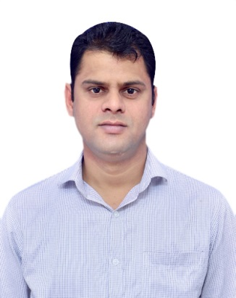
YATENDRA SINGH
Street No-3, Village-Chhalera
Sector-44
Noida-201301
Uttar Pradesh
Mail- yatendrasolanki8791@gmail.com
Mobile- 8448395151/9650106431

YATENDRA SINGH
MBA(Marketing) with 5 years work experience of consumer durable in channels and Corporate Sales in Delhi & NCR.
Seeking Higher level assignments in Sales & Marketing & Channel Management, with an organization of high repute.
Key Skills: Channel Sales Management/Direct sales Management/Key Account Management

Brief Profile

Work Experience: 5 Year(s)
Current Employer (Designation): Ceasefire industries Pvt. ltd [Business Manager]
Annual Salary : (INR) 4.20 Lac(s) (Plus Incentive)
Functional Area (Role): Sales / Business Developer Manager
Industry: Consumer Durable
Highest Degree: MBA(Marketing)
Current (Preferred Location) : Delhi NCR (Noida)
Date of Birth (Gender): 08 July 1987 [Male]

Summary of Skills and Experience
Current Job Profile: Channel Sales Management, Business development, Team management, Corporate sales, Project Sales

Work Experience- 5 Years

Duration: 20th March, 2017 to till date.
Company: Ceasefire Industries Pvt. Limited
Designation: Manager-Business Development
Job Profile: Responsible for sales plan & Responsible to get business from major Key accounts, corporate account and Channel Partners of Noida.

Duration: 3rd, March 2014 – 28th February, 2017
Company: URS Certification Limited
Designation: Sr. Marketing Executive (Business Development).
Job Profile: Development of New Accounts, Key A/C management, Sales Development.

Education

- 10th. Board of High School and Intermediate Education Uttar Pradesh.
- 12th. Board of High School and Intermediate Education Uttar Pradesh
- U.G.: B.Sc.(Physics, Math, Chemistry) from Dr Bhimrao Ambedkar University Agra.
- P.G.: MBA (Marketing) from Punjab technical University.

Professional Profile

- Managing Delhi/NCR region as a Business Manger to generating business of fire safety product products to achieve 100% results.
- Possess excellent interpersonal, communication skills with demonstrated abilities.
- Presently working with Ceasefire Industries Pvt ltd as a Business Manager of Delhi/NCR and responsible for the business of fire extinguisher, fire alarm from Dealers, manufacturing industries, corporate and project management consultant.
- Demonstrated skills in client servicing, relationship management and distribution management.

Current Employment Profile
Ceasefire Industries Pvt. Ltd.
Business Manager (Business Development)
April'03-2017 – Till date
Ceasefire has been established in 1980 and continuously setting standers in the fire Industry. Today Ceasfire is the market leader in almost all product segments of fire safety’s products like fire extinguishers, smoke detectors and another security system in India.
Notable Accomplishments:
- I have exceeded my sale goals every quarter and I have earned incentive each year.
- Won Best rising stars award of Noida territory in Ceasefire (October-2017).
Job Profile:

- Meet with HR, Admin and director of manufacturing industries, corporate client, SME Client and give them presentation of various product and convert them into business.
- Cold calling in my territory and meet with concern person for the business.
- Meet with architect, Builder, PMC for new upcoming project.
- Build relationship with clients and the vendors to establish long term business growth.
- Work closely with the channel partners in identifying key influencers for upcoming projects.
- Handle project liaison and coordination activities for any new establishment or the existing one..
- Conducted on-site inspections of sites to ensure fire protection standards met.
- Contacted customers by phone and email in response to enquiries and meet my target.
- Launched various advertising & promotional activities for business enhancement & better brand awareness.

Previous Employments Profile

URS CERTIFICATION LIMITED
Sr. Marketing Executive
March 2014 to February 2017
URS, a Global Company, operating in more than 30 countries within the multinational URS Holding group and maintains highest value of reliability in its assessment process. More than 40,000 clients has reposed confidence in URS as their Certifying Body to different certifications. Clients certification cover all industrial, Transport, Aerospace, Banking and other Service Sectors- Private, Semi Govt and Government.

The Role.
- Meet with HR, Admin and director of manufacturing industries, corporate client, SME Client and give them presentation of ISO Certification.
- Cold calling in my territory and meet with concern person for the business.
- Converting given prospect leads into client.
- Dealing with various Pre-Sales and Post-Sales Activity.
- Responsible for customer query and following with them for maximum customer satisfaction.
- Working to deadline and target.
- Responsible for achieving monthly target.
- Contacted customers by phone and email in response to enquiries and meet my target..

Affirmative Action
Category: General
Physically Challenged: No

Work Authorization
Countries authorized to work in: India
Job Type: Permanent
Jobseeker Employment Status: Full time

IT Skills
Windows,MS office, Internet and Data Mining.

Personnel Detail

Date of Birth : 08th July 1987
Marital status : Unmarried
Address : House no-.172/3, Avash Vikash Colony,Kasganj, UP-207123
Languages Know : English, Hindi
Father's Name : Mr. Mahendra Singh Solanki
Mother' Name : Mrs. Satyabati
Nationality : Indian

Declaration
I, Yatendra Singh, hereby declare that the information contained herein is true and correct to the best of my knowledge and belief.

___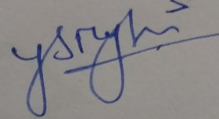_________________________
Yatendra Singh Noida, Uttar Pradesh

